|  |  |
| --- | --- |
| **Project – External Documentation** |  |
| COMP6051016  Web Programming |
| Even Semester Year 2022/2023 |

* Project Title

Jramedia

* Introduction

This project is intended for our class project named Web Programming class in Binus University. The main goal of this project to create website by Laravel framework. Our project name is JRamedia, this is a website of selling book or stationery with the form like e-commerce.

* Report / Documentation

1. Login Page

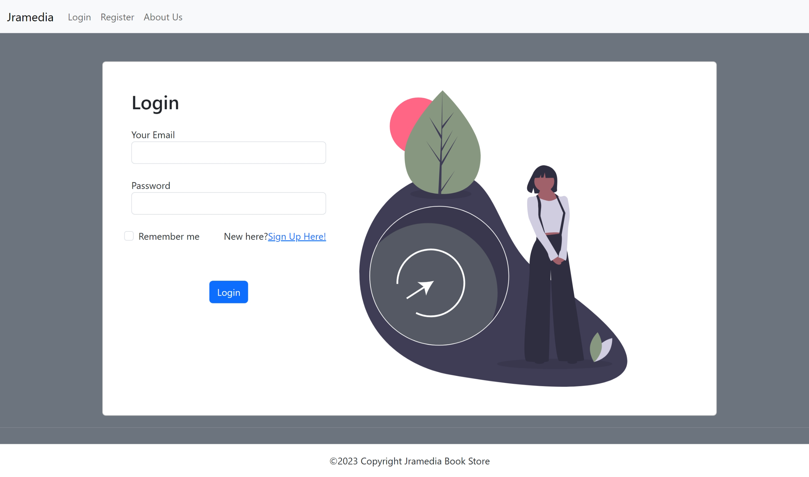

1. Register Page

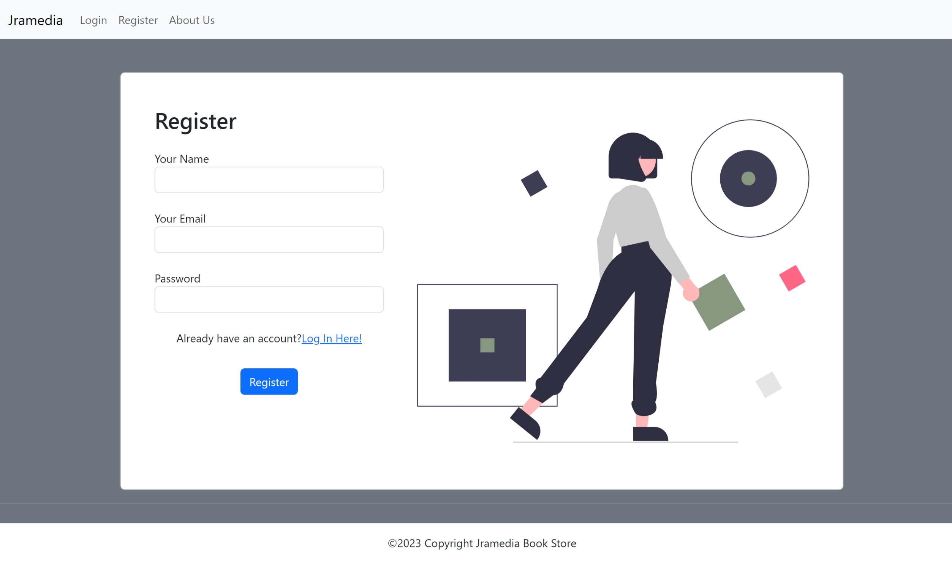

1. Home Page

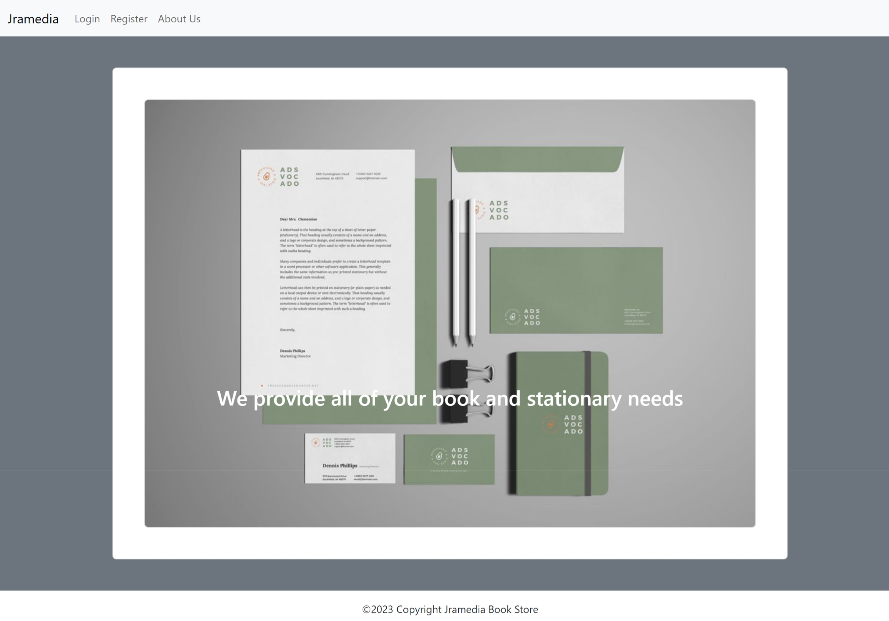

1. Admin Home Page

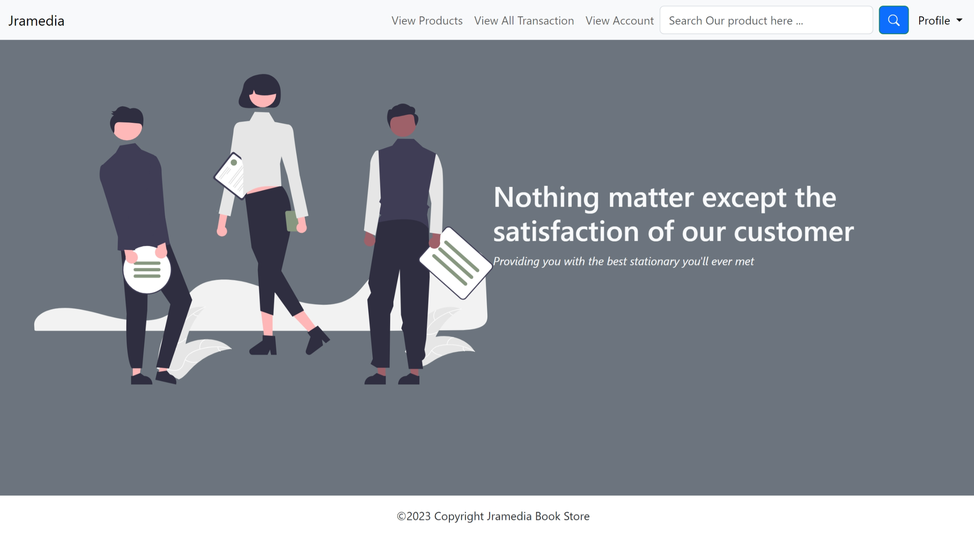

1. Customer Home Page

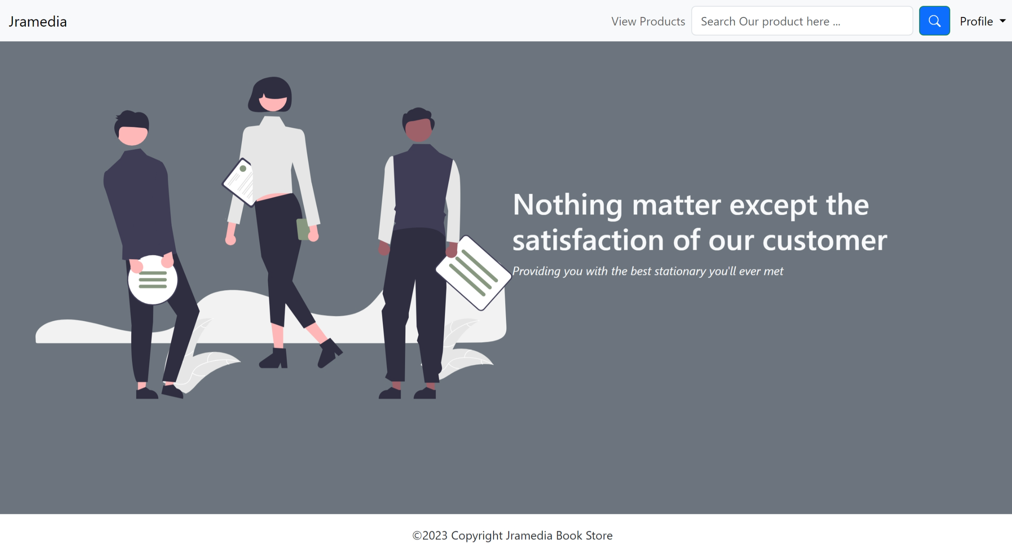

1. Admin View Product Page

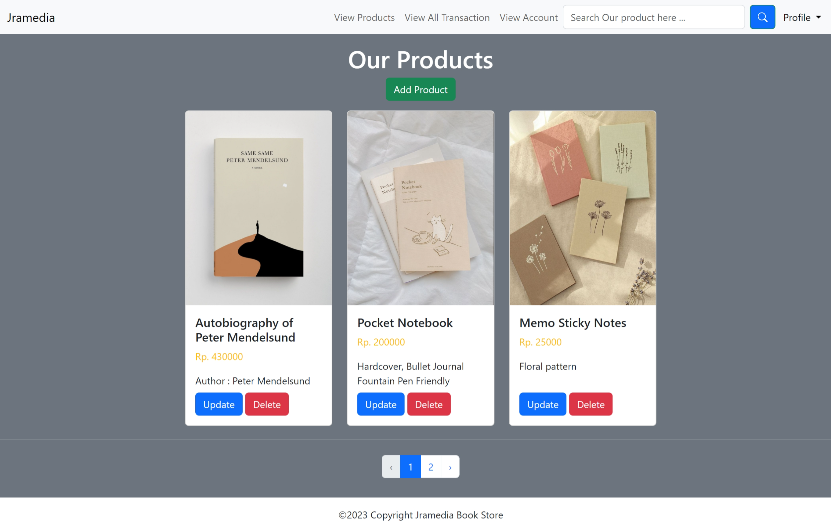

1. Customer View Product Page

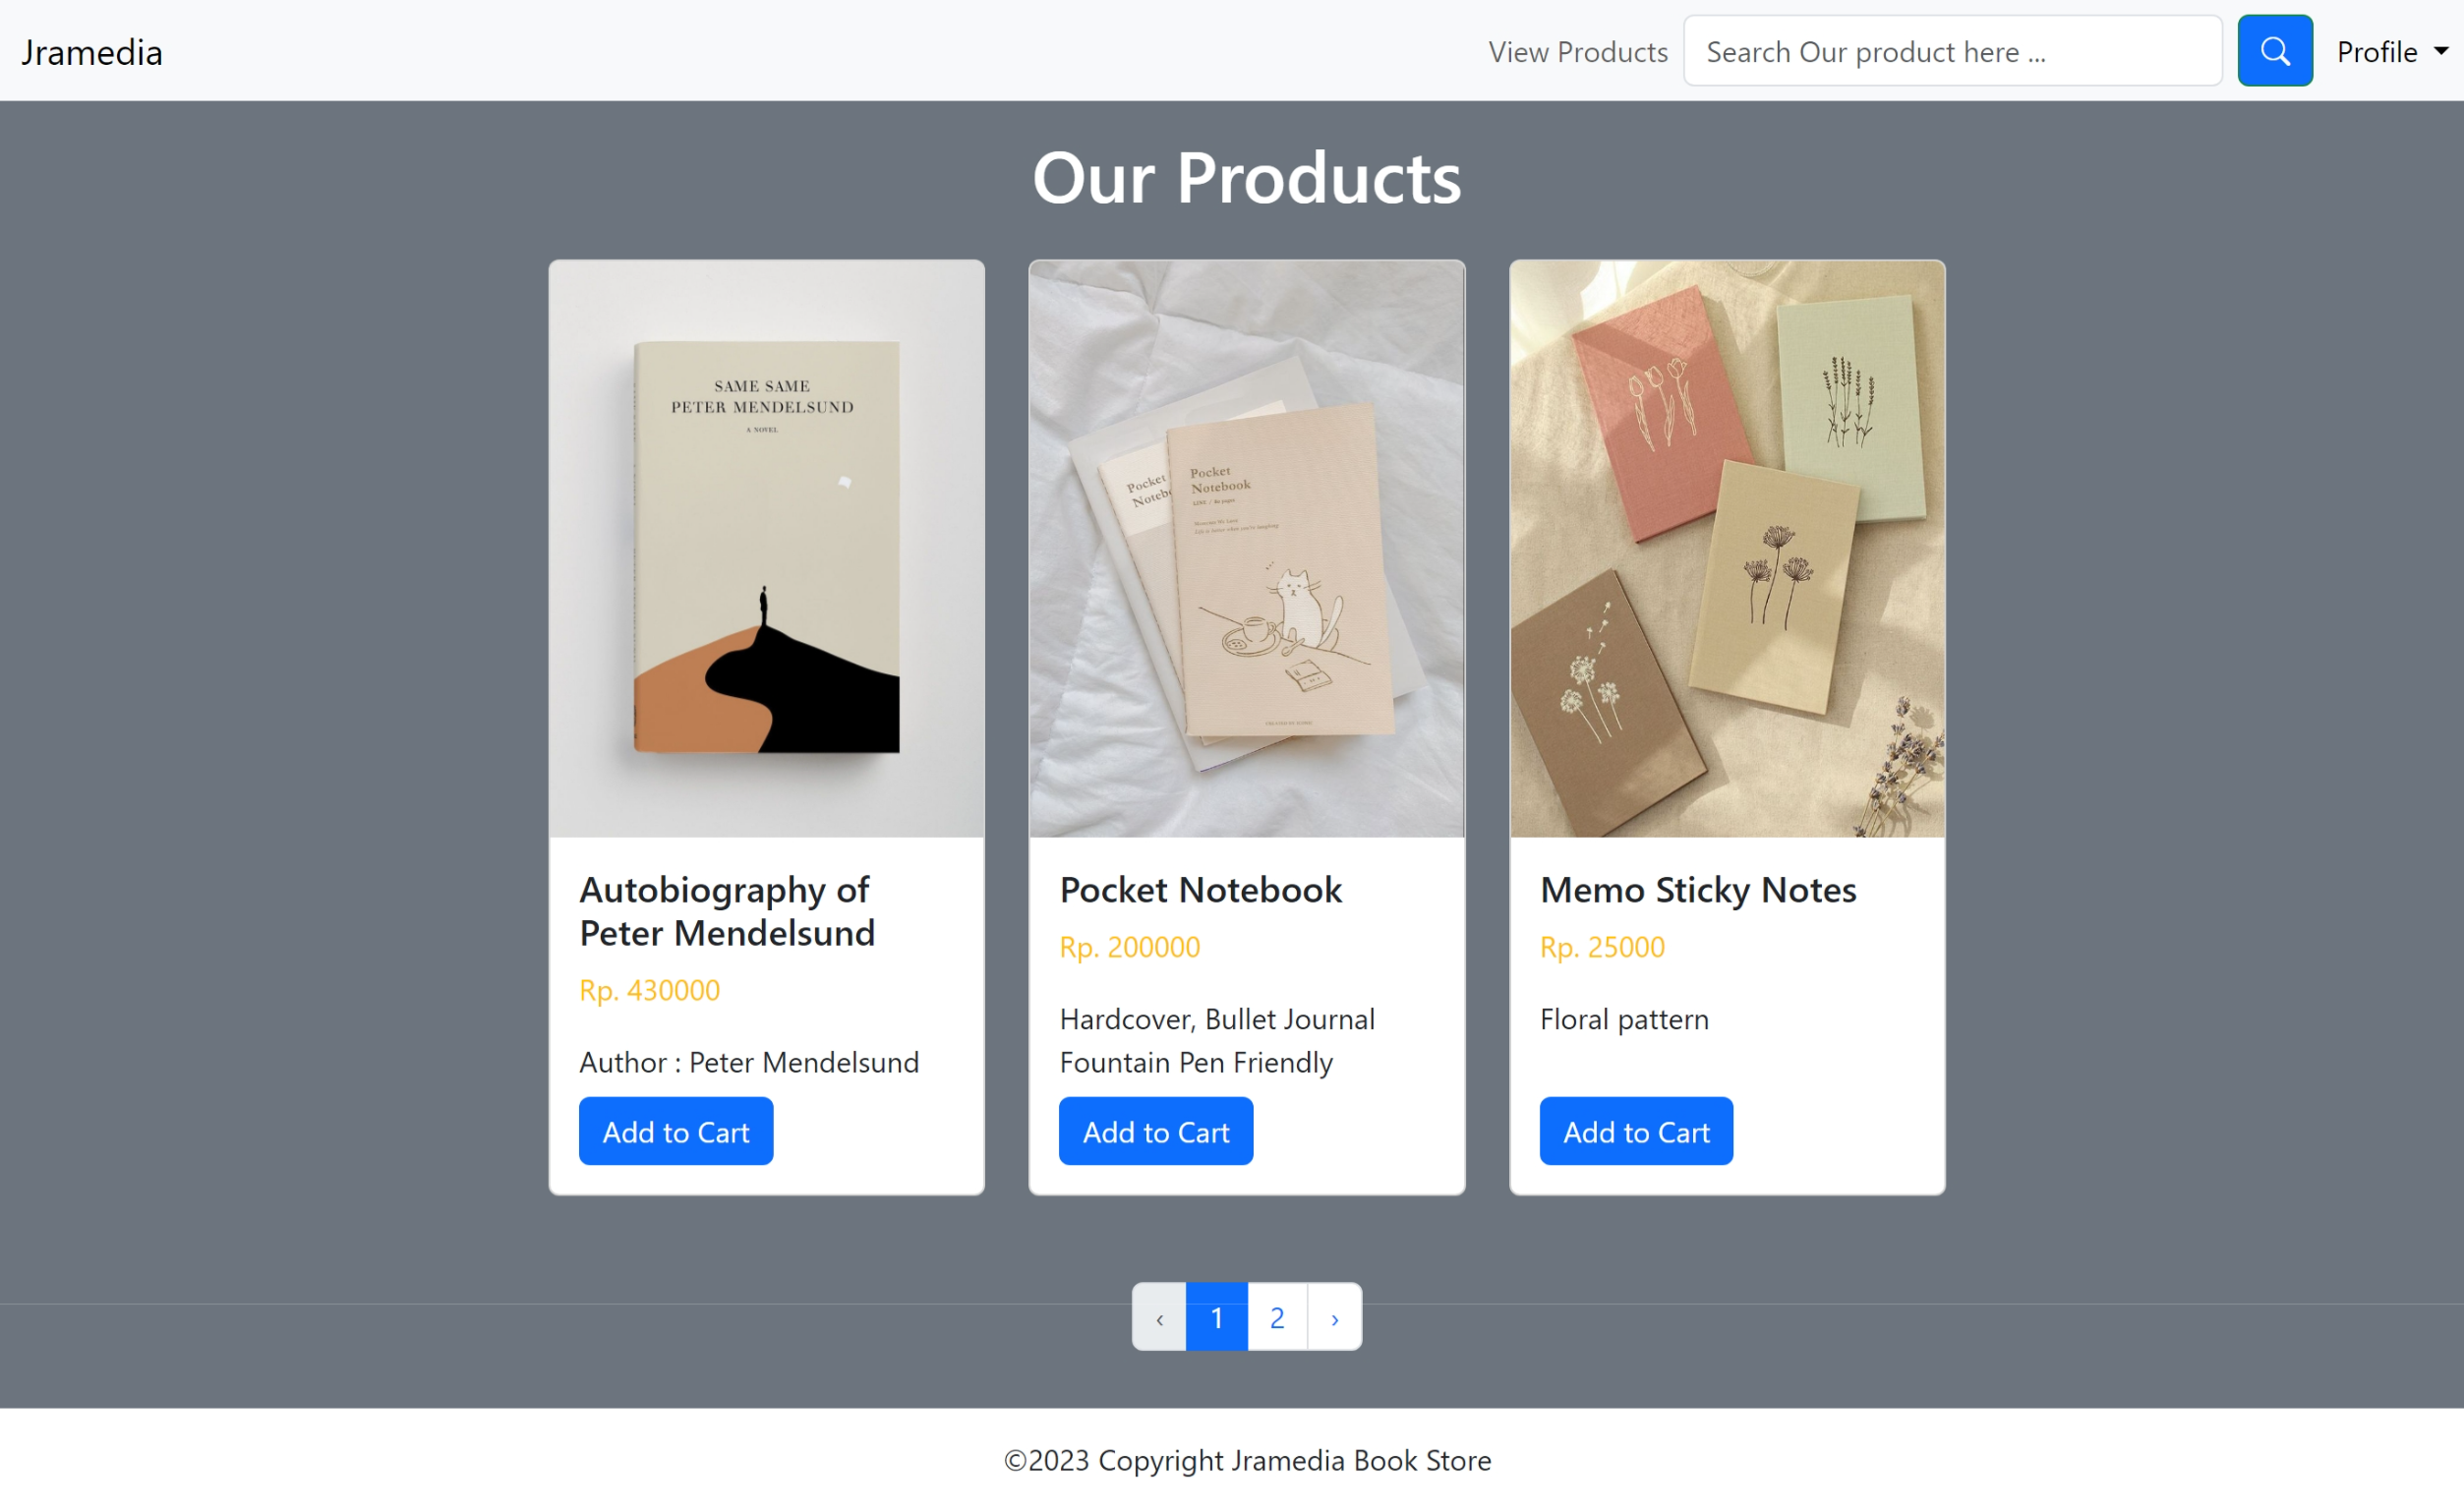

1. Customer My Cart Page

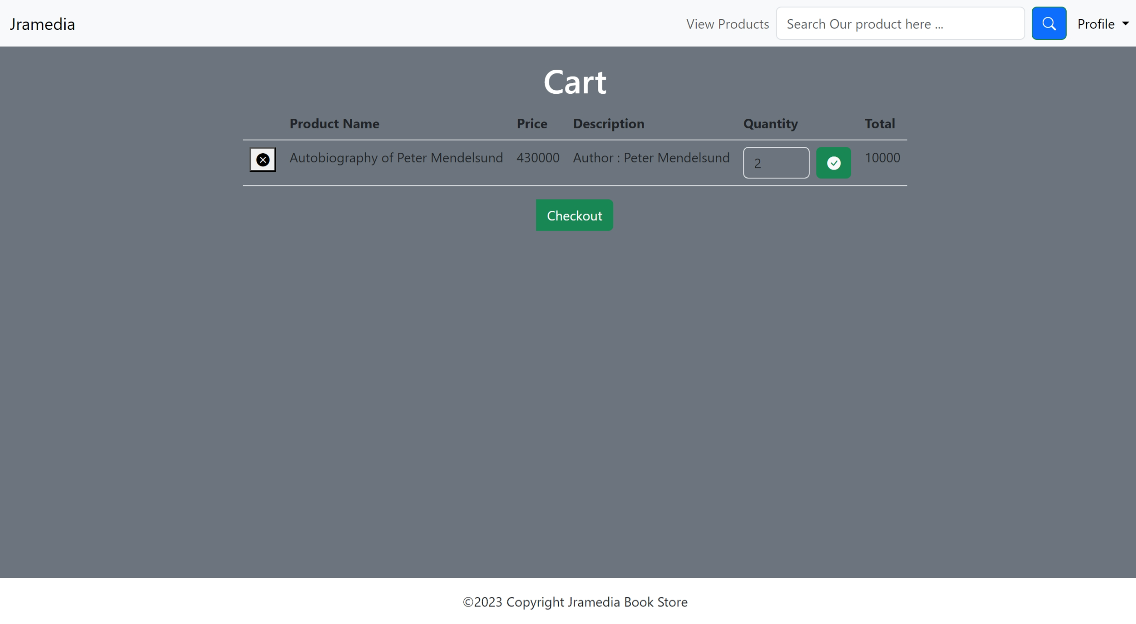

1. View All Transaction Page

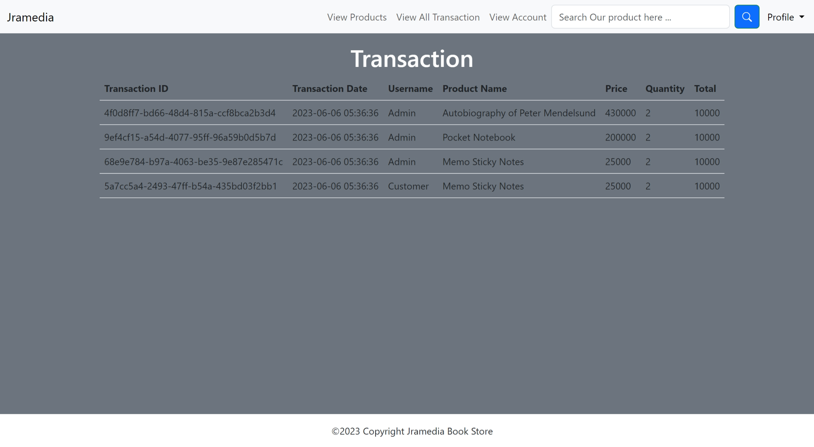

1. View Account Page

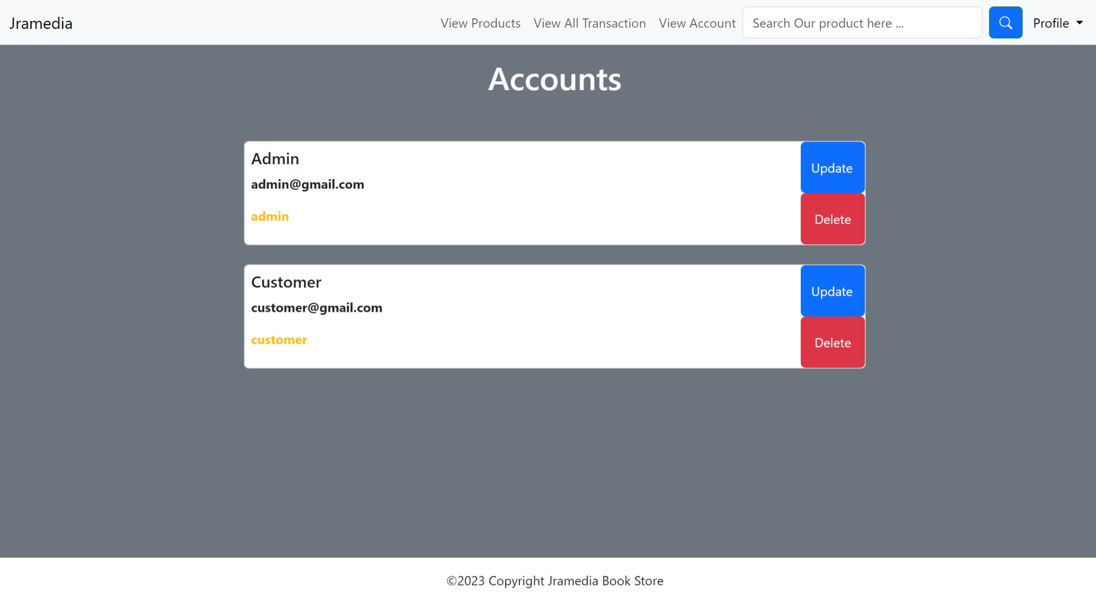

1. About Us

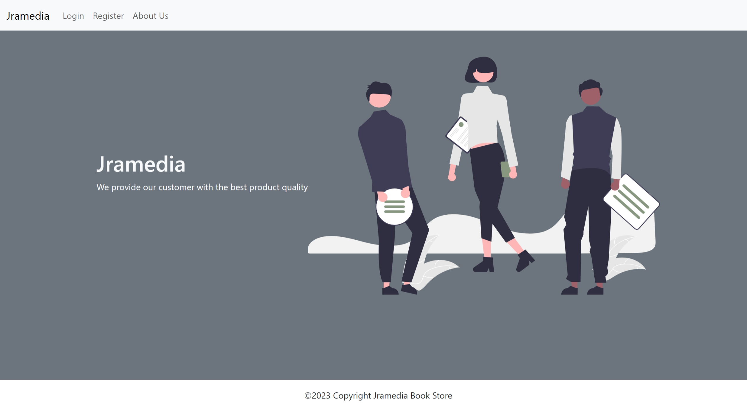

* Reference
* https://www.behance.net/gallery/65552711/Stationery-Branding-Mock-Up
* https://www.petermendelsund.com/
* https://pin.it/453GOdm
* https://pin.it/IbdNqVV
* https://pin.it/4BTt6F6
* https://pin.it/7wV9kWZ
* https://undraw.co/
* Group Member
* 2301911842– Alyssa Imani
* 2301863023 – Karel Tan